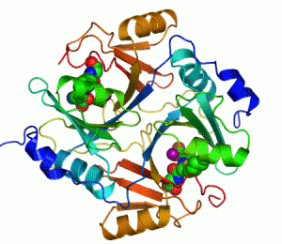 | 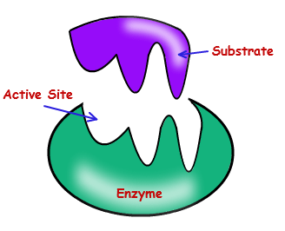
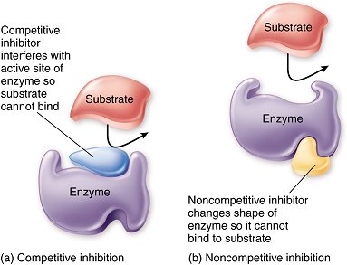 | 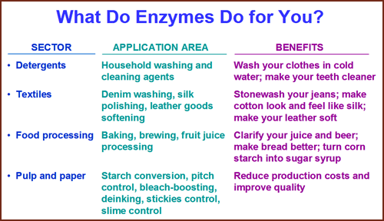

Source:
http://upload.wikimedia.org/wikipedia/commons/a/ae/GLO1_Homo_sapiens_small_fast.gif
http://www.tokresource.org/tok_classes/biobiobio/biomenu/enzymes/competitive_inhibit_c_la_784.jpg
https://biochemanics.files.wordpress.com/2013/04/competitive_inhibit_c_la_784.jpg
http://www.edt-enzymes.com/images/enzymes.gif

Name(s): ___Pamela Esprívalo Harrell_
Date/Time: 2 days (180 minutes)
Name of Course, Grade, and Level: __Biology I______

Science Topic | Enzyme Activity and Regulation

Title of Lesson: Breaking up can be easy to do
Concept Statements:
- Enzymes are proteins that catalyze enzyme reactions.
- Enzyme efficacy is influenced by nonspecific variables (i.e., pH, temperature, and concentration).
- Enzyme inhibitors (i.e., organic chemicals, inorganic metal, or biosynthetic compounds) reduce or completely inhibit enzyme catalytic action via interactions with the enzyme active site.

Source of Lesson:
Harrell, P. E. (2014). BIO 9 (C) Simply Outrageous Science.

List of appropriate TEKS: Chapter 112.34 Biology
TEKS # | Student Expectation
BIO 9 (C) | Identify and investigate the role of enzymes
BIO 2 (C) | Know that scientific theories are based on natural and physical phenomena and are capable of being tested by multiple independent researchers. Unlike hypotheses, scientific theories are well-established and highly-reliable explanations, but they may be subject to change as new areas of science and new technologies are developed;
BIO 2 (H) | organize, analyze, evaluate, build models, make inferences, and predict trends from data;
BIO 1 (A) | Demonstrate safe practices during laboratory and field investigations;

 | Objectives | Evaluation Questions
1 | What is the role of an enzyme within cells? | What is the function of an enzyme?
2 | Explain enzymatic specificity. | Create and label a drawing that denotes the relationship between an enzyme’s active site and the substrate’s shape/charge.
3 | Compare and contrast the Induced Fit Theory of Enzyme Action with the Lock and Key Theory of Enzyme Action. | Describe the difference between the lock and key and the induced fit theory for enzyme interactions.
4 | List and explain two types of inhibitors used to regulate enzymatic activity. | Illustrate and describe the concept of competitive and noncompetitive inhibition.
5 | Describe three reversible inhibitors and give an example for each type. | Describe three reversible inhibitors and give an example for each type.
6 | Name 3 variables that affect enzyme activity. | Name 3 variables that affect enzyme activity.

Resources, Materials, Handouts, and Equipment List in the form of a table:
ITEM  (Specify worksheets) | Quantity  (How many do you need?) | Source  (Who is responsible? | List who this is for (teacher, student, group)
Fresh pineapple  canned pineapple  cheese cloth  food processor  Jell-O™  Bowls  graduated cylinder  Lab apron.  Timing device | 1  1  60 cm.  1  1 box = 6 groups  2 per group  2 per group  1 for each student  1 per group | teacher | students
Enzyme Action Kit (3-D Molecular Designs)  http://www.shop3dmoleculardesigns.com/Enzymes-in-Action-Kit-p/eak.htm | 1 set each group | teacher | students
5 E Lesson Plan for Enzyme Action with Blackline Master handouts for Explore and Elaborate Activities. Fruit Enzyme Handout | 1 for each student  1 for the teacher | teacher | teacher and student
Blackline Master for Nonspecific Inhibitors | 1 for each student | teacher | student
Presentation | 1 | teacher | teacher

Advanced Preparations:
- Copy student handouts for the 5E Explore, Elaborate, and Fruit Enzyme Handout.

- Prepare Jell-O™ one day before the activity. Follow standard directions on the Jell-O box. Once Jell-O is firm, cut into 3 cm cubes. Two cubes for each group are required.

- Puree fresh pineapple in a blender. Strain resulting puree through a cheesecloth to remove any pulp from the juice. Pour into a container labeled “fresh pineapple.”

- Puree canned pineapple in a blender. Strain resulting puree through a cheesecloth to remove any pulp from the juice. Pour into a container labeled “canned pineapple.”

- Prepare visual vocabulary cards; one set for each group of students.

- Pre-assign students to lab groups.

Safety:
- Wear a splash apron throughout the entire lesson to protect clothing.

- Do not taste or eat any of the materials.

- Horseplay and improper use of chemicals and equipment in the lab will result in removal from lab.

- Notify teacher and clean up spills immediately.

- Dispose of materials in the designated waste container provided by the teacher.

5E Lesson Plan

Objective Statement: Students will describe various uses, functions, and mechanisms used by enzymes involved in the breakdown or synthesis of molecules.

ENGAGEMENT Time : Minutes 5 minutes
What the Teacher Will Do | Probing/Eliciting Questions and Students Responses | What the Students Will Do
Good afternoon! My name is Dr. Harrell.  I have a visitor with me today who has lost her pancreas to cancer. Shirley is going to share with you how she adds enzymes (enzyme replacement therapy) to her body each day in order to live.  The visitor will share a typical day, the frequency and products she uses.  Dr. Harrell will facilitate a few questions. | Visitor will answer these questions:  How often do you use the enzyme replacement products?  What is the cost of these products?  Are there any special precautions for storing these products?  What would happen first if you missed your enzyme replacement therapy? | Students are listening to the visitor describe her enzyme replacement therapy.  Students may ask specific questions, however, detailed responses may be written down and saved for the later debriefing activity.

Transition Statement
Now that Shirley has shared her story about enzyme replacement therapy, we are going to explore the question: Why would it be a mistake to add a fruit like pineapple to Jell-O™?

EXPLORATION Time: 30 Minutes
What the Teacher Will Do | Probing/Eliciting Questions and Student Responses | What the Students Will Do
Prepare and organize the materials for the learning experience.  Instruct student group leaders to collect two bowls and 2 graduated cylinders, lab aprons, Explore Handout, Elaborate Handout, and the Fruit Enzyme Handout.  Review the lab safety protocol.  Monitor students and assist as required.  Ask students to read the lab protocol (1-2 minutes), then call on students to describe the steps necessary to complete the lab.  One student will record a narrative about their observations of the effect of fresh and canned pineapple juice on Jell-O™ for each five minutes interval (maximum 30 minutes) while a second student creates a total of six 2-line drawings for each five-minute interval.  While the experiment is running, each group will read, discuss, and take notes about enzyme uses. | Why do we need to wear a splash apron today? To protect clothing from splashes.  What should you do in the event of a spill? Notify the teacher and clean up the spill.  When the lab is finished, what is done with the materials? They are disposed of in the container designated by the teacher.  Use the Fruit Enzyme Handout as a resource of information to create a data table. List and describe at least 5 common uses of enzymes. Include the source of the enzyme, the name of the enzyme, and its use. Answers will vary but might include: Papaya (Papain) as a meat tenderizer, or enzyme used to treat wounds or jellyfish stings; Kiwi (Actinidin) a dietary supplement; Pineapple (Bromelain) a dietary supplement; Fig (Ficin) deworming medicine; various Proteases to break down protein, Amalases to break down starch, and Lipases to break down fats. | Students will record narrative and 2-line drawings/photos for each 5-minute interval of the experiment.  Students will wear lab aprons to properly protect their clothing.  Students will read the Fruit Enzyme Handout and create a table to describe the common uses, names, and origin of five common enzymes.  Students will dispose of all used chemicals properly and clean all equipment when they are finished with the experiment before moving on to the next experiment.
Transition Statement:
Now that we have investigated and collected evidence about how fresh and canned pineapple affect the breakdown of Jell-O™, and have discussed common uses of enzymes, let’s put this evidence together to make some claims about the function and use of enzymes in everyday life.

EXPLANATION Time: 10 Minutes
What the Teacher Will Do | Probing/Eliciting Questions and Student Responses | What the Students Will Do
First, debrief students as you ask questions about the results of the experiment.  Second, provide information about the nature of collagen.  Jell-O is composed of collagen protein that is naturally produced in animals. It is the main component of connective tissue (e.g., in the ears, nose and muscles). As a product, collagen is extracted from animal bones and skin and then purified. Uses of collagen include cosmetics that plump and firm the skin, as a food product (e.g., gummy bears, gelatin desserts) and in the creation of artificial skin to treat severe burns. Medical uses of collagen involve use of recombinant DNA technology that introduces the gene for human collagen into yeast).  Provide information about proteases such as bromelin.  The pineapple plant is a bromeliad. Other common fruits that belong to this group of plants include papaya (enzyme is papain) and kiwi (Actinidin) and fig ((Ficin).  Extend knowledge to include detergent enzymes (Bacillus Protease), meat tenderizer (Papain), disinfectants for wound treatment (Trypsin); prevention of crystals in ice-cream (Lactase) deworming medicines for humans and domestic animals (Ficin)  After discussing the experiments, the teacher will explain the terms enzyme, catabolic processes, and catalyst. | Describe the results of adding fresh pineapple juice to Jell-O™. The Jell-O™ began to break down and this disintegration increased over time.  Describe the results of adding canned pineapple juice to Jell-O™. The Jell-O™ broke down a little and there was little change over time.  Compare and contrast the two results. Make inferences about the different observations. Form some reason, the fresh pineapple was more potent in terms of breaking down the Jell-O™. Since enzymes are denatured by heat, the canning process would have destroyed the some natural substance (bromelin enzyme) in the pineapple.  Based on the results of this experiment, what claim might you make about enzymes; what they do and how they are affected by temperature? Enzymes are involved in catabolic processes. That is they break down certain substances. The enzymes are also affected by variables such as temperature which is why the canned pineapple juice had little effect on the Jell-O™.  What did you learn from the reading materials about enzyme uses? Answers will vary, but should include common uses of enzymes to aid digestion, clean clothing, and treatment of wounds. The names of specific enzymes and the source of the enzyme are also discussed. | Students will answer questions using observations and inferences from the learning experience.  Students will share photos and/or scientific drawings as evidences on which to base their explanations about the effect of fresh and canned pineapple juice on Jell-O™.

Transition Statement
Now that you understand a little about how enzymes help digest materials, we will specifically look at how this works on a molecular level and expand our knowledge about enzymes in everyday life.

ELABORATION Time: 10 Minutes
What the Teacher Will Do | Probing/Eliciting Questions and Student Responses | What the Students Will Do
Assemble the Enzymes in Action Kit materials.  Make copies of the Blackline masters for the Enzyme learning experience.  Monitor students and assist as required. Provide just in time feedback. | ENZYMES – CATABOLIC  Questions.  - What happens when you pull on the molecule of lactose? The glucose and galactose molecules are separated. These are called products of the interaction.  - Some people are lactose intolerant? How do you think this mechanism works in their body? These individuals do not produce enough of the lactase enzyme and so the undigested lactose stays in their body until it is broken down by bacteria. During the meantime, this person may experience nausea, gas, bloating, stomach ache, and diarrhea.  - What do you notice about the Lactase enzyme? The enzyme is unchanged.  - What do you notice about the fit between the enzyme and the substrate? They fit together like a puzzle piece. There was a slight shape change when they were pulled apart.  ENZYMES – ANABOLIC  Questions:  - What happens when you pull on the DNA building blocks? The nucleotides stay together. These are called products of the interaction.  - Explain why this is an example of anabolism? The building blocks of DNA are brought together to form a product.  - What do you notice about the DNA polymerase enzyme? The enzyme is unchanged.  - What do you notice about the fit between the enzyme and the substrate? They fit together like a lock and key. Unlike catabolism, the enzyme did not change shape once the small building block of DNA was in the active site.  COMPETITIVE INHIBITION  Questions:  - What happens when the competitive inhibitor, Antabuse interacts with the enzyme?  The normal metabolism of alcohol is prevented and toxins build up in the body making the person sick. This stops further products from being formed.  - What happens when the substrate, acetaldehyde interacts with the enzyme acetaldehyde dehydrogenase? The alcohol continues be metabolized...  - What do you notice about the acetaldehyde dehydrogenase enzyme? The enzyme is unchanged.  - What do you notice about the fit of the substrate and the competitive inhibitor? The competitive inhibitor fits within the active site and blocks the substrate.  - How would a very low dosage of Antabuse affect an individual? The effects would not be as severe if the concentration of the competitive inhibitor was low.  - What do you notice about the polarity of the enzyme and substrate? This particular active site is specific with regard to polarity.  NONCOMPETITIVE INHIBITION  Questions:  - What happens when the noncompetitive inhibitor, Nevarapine interacts with the enzyme?  The active site experiences a shape change and the interactions which synthesize viral DNA are stopped.  - Since Navarapine does not bind to the active site, what happens to the HIV? The HIV remains in the body, but the production of HIV slows so there are fewer HIV-infected cells.  - What inferences might be made about the concentration of Nevarapine in the body? With an appropriate dosage of Navarapine, it is more likely that the cells will remain uninfected.  - How is noncompetitive inhibition different from competitive inhibition? There is no occupation of the active site; there is a shape change to the active site, the concentration of the substrate during noncompetitive inhibition is inconsequential. | The student will engage in the simulation using the self-guided learning activity.  The students will answer the questions and make drawings to demonstrate their understanding of the lesson content.  Students will participate in discussion and debriefing for each of the four activities.

Transition Statement
Now that we have explored the molecular aspects of enzyme/substrate interactions, let’s summarize our knowledge.

Closure Statement
Today we have studied enzymes, their role in building and breaking apart molecules associated with maintaining homeostasis in our body. We learned that enzymes help us in many ways such as digestion of food, washing our clothes, caring for our wounds, and improving life using drug therapies. A key component is that enzymes are specific catalysts for chemical reactions and they are never consumed during their interactions with substrates. Variable such as temperature affect enzymes and can slow or speed them up.

EVALUATION Time: 5 Minutes
What the Teacher Will Do | Probing/Eliciting Questions | What the Students Will Do
Prepare the assessment questions on paper. Administer the assessment using typical test security precautions.  Evaluate the student’s answers and provide feedback. | - Name four types of macromolecules.  a. nucleic acids  b. carbohydrates  c. proteins  d. lipids  - What is the function of an enzyme? The function of an enzyme is to act as a catalyst for chemical reactions. Enzymes function in catabolism and anabolism of molecules. They lower the activation energy needed to drive reactions, thus preventing damage to the cell. Enzymes may prevent the next step in a cascade of reactions.  - Describe the difference between the lock and key and the induced fit theory for enzyme interactions. Lock and key: the substrate fits exactly into the active site of the protein during anabolic activity. Induced fit: During catabolic reactions, the enzyme recognizes the substrates, then slightly changes its shape, bringing the substrates together.  - Name variables that affect enzyme activity?  Temperature  pH  - Name two types of inhibitors other than reversible inhibitors.  Nonspecific  Irreversible  - Describe three reversible inhibitors and give an example for each type.  - Competitive: Example: Oxygen binds to a specific site on hemoglobin molecules. Carbon monoxide can also bond to this same site, which can cause death via carbon monoxide poisoning. Other Examples: antihistamines, Antabusee treatment for alcoholics, protease penicillin  - Noncompetitive allosteric: Example: heavy metals  - Uncompetitive: Example: HIV drug Nevirapine | Without assistance, the students will individually complete the assessment questions.

Blackline Master
Fruit Enzyme Handout
Explore

Source: biotechlearn.org.nz/themes/biotech_at_home/fruit_enzyme_uses

Fruit enzyme uses
Enzymes extracted from fruits like papaya, pineapple, kiwifruit and fig have uses as medicines, food-processing agents and dietary supplements.

Fruits contain enzymes
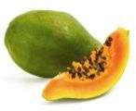
Fruits like papaya, kiwifruit, pineapple and figs all contain enzymes called proteases. Proteases speed up the breakdown of proteins.

Uses of fruit enzymes
Fruit enzymes that break down proteins have many potential uses. For example, papain, the protease enzyme from papaya, is used for tenderizing meat, treating wounds, dietary supplements and removing particles from cold beers.
Plant | Protease | Uses
Papaya  (or pawpaw) | Papain | - Meat tenderizer  - Clarifying cold beers  - Dietary supplement  - Wound treatment  - Treating jellyfish stings and insect bites  - Clotting milk  - Treating wool to prevent shrinkage
Kiwifruit | Actinidin | - Dietary supplement
Pineapple | Bromelain | - Dietary supplement  - Wound treatment
Fig | Ficin | - Deworming medicine

Source: biotechlearn.org.nz/themes/biotech_at_home/fruit_enzyme_uses

Kiwifruit enzyme may aid digestion
PhloeTM – a kiwifruit-based dietary supplement developed by New Zealand company Vital Foods and launched in 2007 – has proven benefits in regulating bowel movements with no side effects such as cramps or diarrhea. It is commonly used in hospital wards for treating constipation.
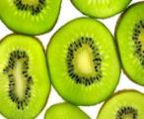
Kiwifruit
Recent research undertaken at the Riddet Institute has confirmed that eating green kiwifruit with a protein-rich meal helps improve digestion of several food proteins. This confirms beliefs that have existed for some time – that enzymes in green kiwifruit can break down proteins for better absorption in the digestive process.

Other uses of kiwifruit enzymes
Over the last 10 years, scientists have shown that fruit enzymes may act as an insecticide, protecting the fruit from attack from insects. Researchers at Plant & Food Research have shown that the protease in kiwifruit can reduce insect growth and survival.

The kiwifruit ate my jelly!
Have you ever eaten a piece of pineapple or kiwifruit and felt a prickly sensation in your mouth? This is caused by proteases acting on the inside of your mouth. They can even cause an allergic reaction in some people.
Whilst fruit enzymes are good for breaking down meat proteins, they also digest other types of protein. For example, if you made a jelly and added some raw kiwifruit or raw pineapple, the protease enzymes will digest the gelatin and stop the jelly from setting properly.

Source: biotechlearn.org.nz/themes/biotech_at_home/fruit_enzyme_uses

Enzymes in washing powders
Television commercials for washing powder often promote the "boosting power" of enzymes. Why are enzymes added to washing powder, and how do they work? Carry out some simple experiments to investigate this further.

What are enzymes?
Enzymes are biological molecules that catalyze (speed up) chemical reactions. Enzymes are specific—they will only work on particular molecules. For example, the enzyme sucrase will only bind with and break bonds in sucrose, not any other type of sugar.
Another characteristic of enzymes is that they can be re-used over and over again. A single enzyme will typically catalyse around 10,000 chemical reactions per second. This means that only a tiny amount of enzyme is needed to have a huge effect on a reaction.
The rate of enzyme activity depends on the amount of enzyme present, and also the temperature and pH of the reaction solution. The most favourable pH for many enzymes is 6-8, around neutral, but there are exceptions: pepsin, a digestive enzyme in the stomach, works best at pH 2.

Enzymes in washing powders
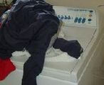
Washing
People have been experimenting with ways to use the power of enzymes to clean clothing for a long time; in fact, the first patent was in 1913.
Because stains are made of different types of molecules, a range of enzymes are needed to break them down. Proteases break down proteins, so are good for blood, egg, gravy, and other protein stains. Amylases break down starches, and lipases break down fats and grease. Washing powders usually only contain one type of enzyme, though some have two or all three.

Source: biotechlearn.org.nz/themes/biotech_at_home/fruit_enzyme_uses

Fruit enzymes tenderise meat
Raw fruits can be used to tenderise meat before cooking because they contain enzymes that break down proteins.
Marinades are usually added to meats such as beef, chicken or pork before cooking. Marinades have two main roles – they add flavour, and they may also tenderise the meat, making it softer and less chewy.
Marinades are a mixture of ingredients that can include acids (typically vinegar, lemon juice or wine), oils, herbs, spices, dairy products, fruits and vegetables.

Natural meat tenderisers
Meat consists of muscle and connective tissues that are made up of proteins. Proteins contain lots of amino acids linked together in chains to make large molecules. Meat tenderisers act by breaking apart the amino acids. Marinades designed to tenderise meat usually contain acids or enzymes.
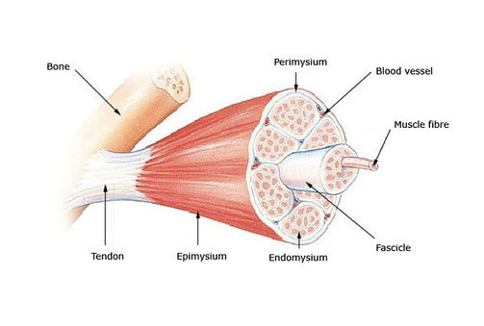
Skeletal muscle structure

Source: biotechlearn.org.nz/themes/biotech_at_home/fruit_enzyme_uses

Acidic ingredients in marinades
Acidic ingredients in marinades like vinegar, wine and lemon juice will tenderise meat by denaturing or unwinding the long protein in the muscle. In fact, if you leave an acidic marinade on a piece of meat for a long time, it will eventually break down all the proteins – leaving behind a mushy mess.

Enzymes in marinades
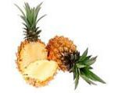
Pineapple
Enzymes can speed up or catalyse the breakdown of proteins into amino acids. For example, fruits like papaya, kiwifruit, pineapple, fig and mango are a good source of enzymes that can break down meat proteins. These fruits all contain a type of enzyme called a protease.

Fruit enzymes work at higher temperatures
Enzymes in our bodies tend to work best around 37 °C. However, enzymes from fruits, such as papaya or pineapple work best between 50–70 °C. If left too long on the meat, they can completely digest it.
Fruit enzymes can be inactivated by high heat. This is the reason that fruits or vegetables are often blanched (dipped briefly in boiling water) before being frozen, because this inactivates the proteases and stops them from discolouring in the freezer.

Tenderising without enzymes
There are other ways to tenderise meat including chopping, mincing or even pounding the meat with a mallet. These methods also break up the muscle and connective tissue, making the meat more tender. Alternatively, cooking the meat slowly for a long time will also make it softer.
Blackline Master
Nonspecific Inhibitors
Pineapple Lab
Explore
Nonspecific Inhibitors
Exploring the Effect of Heat on Pineapple Enzymes

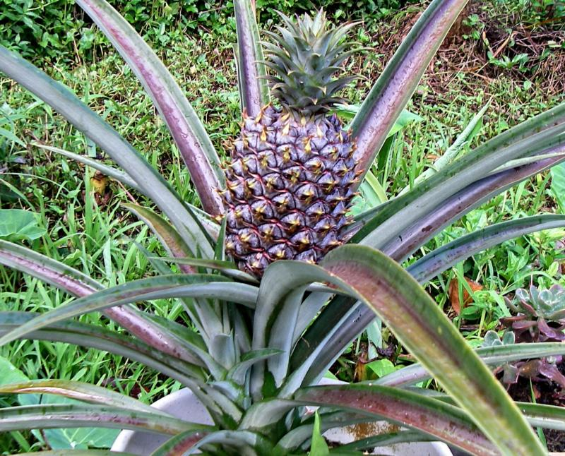  http://nothingright.com/wp-content/uploads/2012/10/Pineapple-Plant1.jpg | The pineapple plant is a bromeliad that is native to tropical areas. The leaves grow in a rosette and are stiff and spiny. It takes two years just to grow one pineapple! Commercially, they are still harvested by hand.  Many people consume pineapple because of its digestive properties that are made possible by the enzyme, bromelin. The function of this pineapple enzyme (bromelin) is to digest proteins. In this learning experience, we will explore how canning the pineapple affects enzyme activity.
Jell-O is composed of collagen protein that is naturally produced in animals and is the main component of connective tissue (e.g., in the ears, nose and muscles). As a product, collagen is extracted from animal bones and skin and then purified. Some uses of collagen include cosmetics that plump and firm the skin, as a food product (e.g., gummy bears, gelatin desserts) and in the creation | 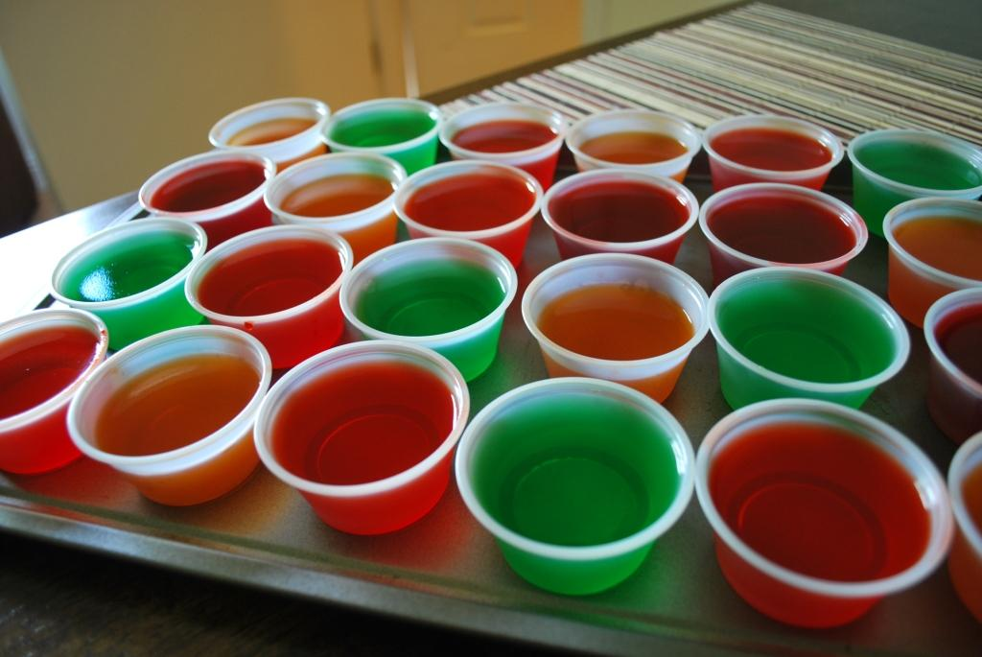
of artificial skin to treat severe burns. Medical uses of collagen do not use animals, but rather involve use of recombinant DNA technology that introduces the gene for human collagen into yeast.

Materials:
Fresh pineapple juice (enough to cover the Jell-O™ cube)
Canned pineapple juice (enough to cover the Jell-O™ cube)
2 Jell-O™ cubes per group
2 bowls per group
2 graduated cylinders per group
Timing device per group
Lab apron for each student
Procedure:

- Adhere to normal lab safety standards. Notify the teacher of any spills which must be immediately cleaned up.
- Collect the materials for the lab.
- Label the bowls (A) fresh pineapple juice and (B) canned pineapple juice
- Place one Jell-O™ cube in each of the labeled bowls
- Cover one Jell-O™ cube with fresh pineapple juice
- Cover the remaining Jell-O™ cube with canned pineapple juice
- Use a timer to record your observations every 5 minutes over a 30 minute period.
- Record observations in Table 1.
- Between observations read the Fruit Enzyme Handout
- Answer the questions.

Questions:
- Describe the results of adding fresh pineapple juice to Jell-O™. The Jell-O™ began to break down and this disintegration increased over time.

- Describe the results of adding canned pineapple juice to Jell-O™. The Jell-O™ broke down a little and there was little change over time.

- Compare and contrast the two results. Make inferences about the different observations. Form some reason, the fresh pineapple was more potent in terms of breaking down the Jell-O™. Since enzymes are denatured by heat, the canning process would have destroyed the some natural substance (bromelin enzyme) in the pineapple.

- Based on the results of this experiment, what claim might you make about enzymes; what they do and how they are affected by temperature? Enzymes are involved in catabolic processes. That is they break down certain substances. The enzymes are also affected by variables such as temperature which is why the canned pineapple juice had little effect on the Jell-O™.

What did you learn from the reading materials about enzyme uses? Answers will vary, but should include common uses of enzymes to aid digestion, clean clothing, and treatment of wounds. The names of specific enzymes and the source of the enzyme are also discussed.
Table 1: Exploring the Effect of Heat on Pineapple Enzymes

Time (minutes) | Observation narrative
5
10
15
20
25
30

Blackline Master
Enzyme Simulation
Elaborate
Enzyme/Substrate Simulation
Catabolism

Did you know that…
Almost all Asians and Native Americans are lactose intolerant. Since their ancestors did not eat dairy products, most of these individuals lack the genes to process lactose. For this reason, they avoid dairy products like milk, cheese, and ice cream or require a little help from products such as Lactaid™ that contains lactase to help them properly digest dairy products ☺

Objective(s)
- Describe enzyme and substrate interactions
- Describe enzyme specificity
Materials:
Gray A foam piece (no stickers and stamped A side up) simulates lactase
Green pieces B1 and B2 (simulates glucose and galactose separately or lactose collectively).

An enzyme is a protein that is able to speed up a reaction in a cell in order to prevent a build-up of heat that would damage the cell. Enzymes lower the activation energy needed to start the reaction. In this simulation, the gray foam piece A represents the enzyme, lactase, which is found in the small intestine of humans. For example, let’s say that you drink a little milk which contains lactose, which is a sugar found in milk. In order for your body to break down the lactose sugar, you need a particular enzyme called lactase in order to break down the lactose into its two simpler forms of sugar (glucose and galactose), which can then be absorbed into the bloodstream. In this simulation, the glucose and galactose are represented by the green pieces of foam (B1 and B2).
- Place the grey foam piece A in front of you. In this simulation, the grey foam piece A represents the lactase enzyme

- Connect B1 with B2 to represent a molecule of lactose. This molecule is often generalized and called the substrate.

- Press and fit the green molecule of lactose into the grey lactase enzyme, then pull on the B1 end of the molecule.
Make a labeled drawing to show the enzyme and substrate before and after the interaction.
Before enzyme/substrate interaction | After enzyme/substrate interaction
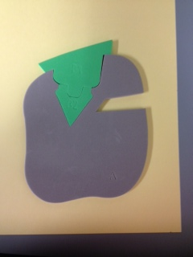  Lactose molecule (substrate)  Lactase enzyme | 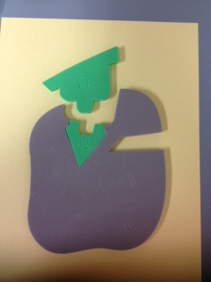  Lactase enzyme  Glucose and galactose molecules (products)

Questions:
- What happens when you pull on the molecule of lactose?
The glucose and galactose molecules are separated. These are called products of the interaction.
- Some people are lactose intolerant? How do you think this mechanism works in their body? These individuals do not produce enough of the lactase enzyme and so the undigested lactose stays in their body until it is broken down by bacteria. During the meantime, this person may experience nausea, gas, bloating, stomach ache, and diarrhea.

- What do you notice about the lactase enzyme? The enzyme is unchanged.

- What do you notice about the fit between the enzyme and the substrate? They fit together like a puzzle piece. There was a slight shape change when they were pulled apart.
During the breakdown of molecules, this stretching of the enzyme to accommodate the substrate is described as Koshland’s theory of Induced Fit.

Enzyme/Substrate Simulation
Anabolism

Objective(s)
- Describe enzyme and substrate interactions
- Describe enzyme specificity
Materials:
Gray A foam piece (no stickers and stamped A side up)
Orange pieces C1 and C2.

In this simulation, the gray foam piece A represents DNA polymerase, an enzyme that is responsible for building and proofreading DNA. For example, let’s say that you spend all day in the Sun on a tropical island. All of the Sun’s radiation bombarding your body creates DNA errors. The enzyme, DNA polymerase is the protein that helps to repair and rebuild damaged DNA. In this simulation, the building blocks of DNA are represented by the orange pieces of foam (C1 and C2).
Make a labeled drawing for each piece of the simulation.

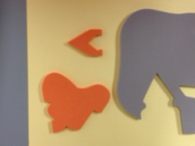
DNA polymerase
enzyme
Nucleotides
(substrate)

- Place the DNA polymerase enzyme (grey foam) in front of you. The stamped “A” side should be touching the table.

- C1 with C2 represent building blocks of DNA. The stamped side of these foam pieces should also be touching the table. These are called the substrate.

- Press and fit the smaller orange molecule into the grey enzyme, then connect the larger orange molecule. Pull on the end of the larger molecule to release it from the enzyme.
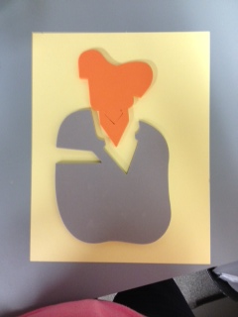
Connected (repaired) building blocks of DNA (product)
DNA polymerase
enzyme

Questions:
- What happens when you pull on the DNA building blocks? The nucleotides stay together. These are called products of the interaction.

- Explain why this is an example of anabolism? The building blocks of DNA are brought together to form a product.

- What do you notice about the DNA polymerase enzyme? The enzyme is unchanged.

- What do you notice about the fit between the enzyme and the substrate? They fit together like a lock and key. Unlike catabolism, the enzyme did not change shape once the small building block of DNA was in the active site.
During the synthesis of molecules, this rigid shape of the enzyme that will accommodate a specific shape is described as the Fischer’s Lock and Key Model.
Enzyme/Substrate Simulation
Competitive Inhibition
Objective(s)
- Describe enzyme and substrate interactions
- Describe enzyme specificity with regard to shape and polarity
- Describe the process of competitive inhibition.
Materials:
Gray A foam piece (stickers and stamped A side down)
Red D foam piece (with stickers)
Purple F foam piece (stamped F side up)

In this simulation, the purple foam piece F represents the drug Antabuse ® which is used in the treatment of alcoholism and makes one sick when drinking alcohol. Antabuse ® causes headaches and vomiting that is so severe that it deters consumption of more alcohol while using the drug. The gray foam piece A represents the enzyme, acetaldehyde dehydrogenase, which is involved in the process of metabolizing alcohol. Acetaldehyde dehydrogenase breaks down acetaldehyde and is blocked by Antabuse ®, a competitive inhibitor.
Make a labeled drawing for each piece of the simulation.
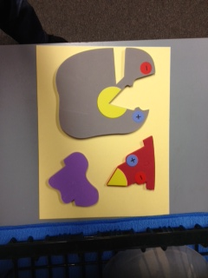
Acetaldehyde
(substrate)
Drug: Antabuse
(competitive inhibitor)
Acetaldehyde dehydrogenase enzyme

- Place the acetaldehyde dehydrogenase enzyme (grey foam) in front of you. The stamped “A” side should be touching the table.

- Red foam D (stamped side up) represents acetaldehyde, the substrate. Connect the enzyme and substrate together.

- Remove red foam D and place the Antabuse ® (purple foam F) in the active site.
Competitive inhibition | Typical enzyme/substrate interaction
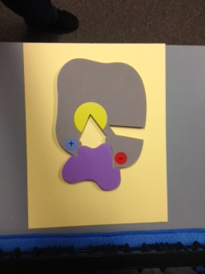  Acetaldehyde dehydrogenase  enzyme  Antabuse | 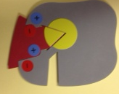  Acetaldehyde dehydrogenase  enzyme  Acetaldehyde  (substrate)

Questions:
- What happens when the competitive inhibitor, Antabuse ®, interacts with the enzyme?
The normal metabolism of alcohol is prevented and toxins build up in the body making the person sick. This stops further products from being formed.
- What happens when the substrate, acetaldehyde, interacts with the enzyme acetaldehyde dehydrogenase? The alcohol continues be metabolized.

- What do you notice about the acetaldehyde dehydrogenase enzyme? The enzyme is unchanged.

- What do you notice about the fit of the substrate and the competitive inhibitor? The competitive inhibitor fits within the active site and blocks the substrate.

- How would a very low dosage of Antabuse ® affect an individual? The effects would not be as severe if the concentration of the competitive inhibitor was low.

- What do you notice about the polarity of the enzyme and substrate? This particular active site is specific with regard to polarity.

Enzyme/Substrate Simulation
Noncompetitive Inhibition

Objective(s)
- Describe enzyme and substrate interactions.
- Describe enzyme specificity.
- Describe the process of noncompetitive inhibition.
- Compare and contrast competitive and noncompetitive inhibition.
Materials:
Gray A foam piece (stickers and stamped A side down)
Blue foam piece G
Purple F foam piece (stamped F side up)

In this simulation, the blue foam piece G represents the drug, Nevarapine ®,which is used in the treatment of HIV. Nevarapine ® attaches to an alternate site (allosteric site) on the enzyme causing the active site to change shape and leave it no longer functional. The gray foam piece A represents the enzyme, HIV reverse transcriptase that is involved in the process of HIV replication. Because, Nevarapine ® does not bind to the active site, but rather alters it through a shape change, it is called a noncompetitive inhibitor.
In this example, the enzyme functions to prevent the next step in a cascade of reactions. This is a key idea in the development of drug therapy.
Make a labeled drawing for each piece of the simulation.
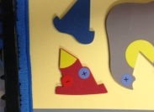
Drug: HIV Nevarapine ®
(noncompetitive inhibitor)
nucleotide
(substrate)
HIV reverse transcriptase enzyme

- Place the HIV reverse transcriptase enzyme (grey foam) in front of you. The stamped “A” side should be touching the table.

- Place the red foam piece D in the active site of the enzyme. This represents an individual with HIV in which the HIV reverse transcriptase enzyme can synthesize viral DNA. The nucleotides represent the substrate.

- The blue foam piece G (stamped side up) represents the drug Nevarapine ®, a noncompetitive inhibitor. Insert the noncompetitive inhibitor into the enzyme. Notice what happens to the active site.
Without drug therapy | Noncompetitive inhibition (with drug therapy)
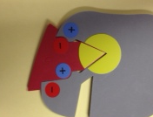  HIV reverse transcriptase enzyme  Nucleotide in active site (substrate) | 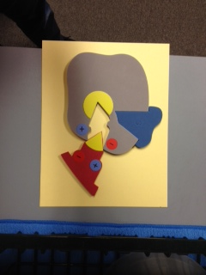  Nevarapine ®  Nucleotide (no longer fits active site)  HIV reverse transcriptase enzyme
Questions:
- What happens when the noncompetitive inhibitor, Nevarapine ®, interacts with the enzyme? The active site experiences a shape change and the interactions which synthesize viral DNA are stopped.

- Since Navarapine ® does not bind to the active site, what happens to the HIV reverse transcriptase? The HIV remains in the body, but the production of HIV slows because there are fewer HIV-infected cells.

- What inferences might be made about the concentration of Navarapine ® in the body? With an appropriate dosage of Navarapine ®, it is more likely that the cells will remain uninfected.

- How is noncompetitive inhibition different from competitive inhibition? There is no occupation of the active site; there is a shape change to the active site, the concentration of the substrate during noncompetitive inhibition is inconsequential.

Now, let’s pull it all together, and keep it straight in terms of scientific knowledge…

Examine the interactive animation to compare competitive, noncompetitive and uncompetitive enzymes:
http://www.wiley.com/college/boyer/0470003790/animations/enzyme_inhibition/enzyme_inhibition.htm
Fill in the missing information on the concept map.

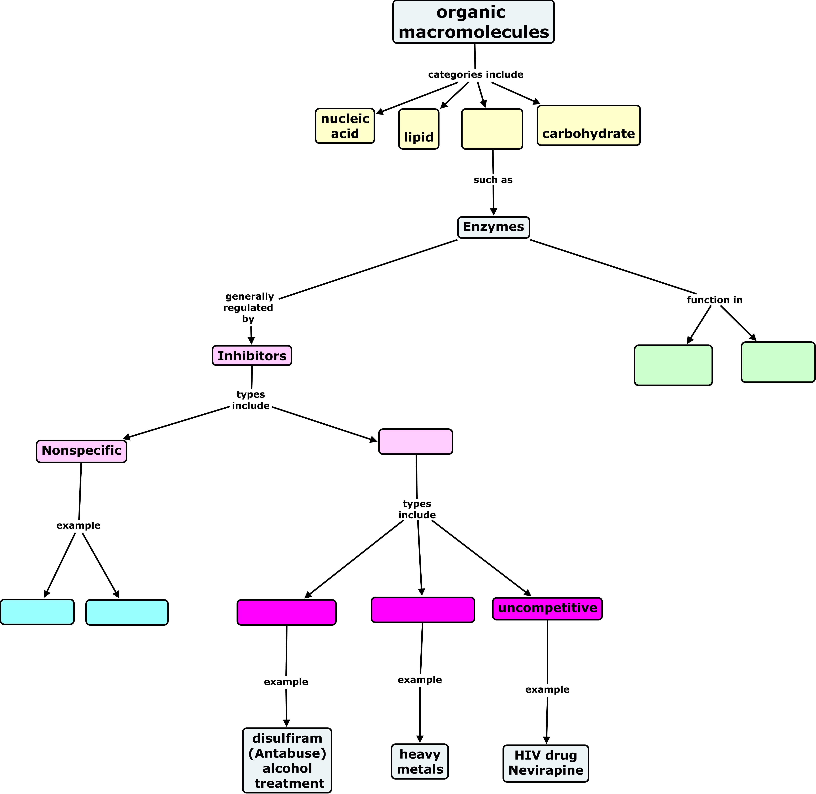
reversible
noncompetitive
competitive
Lowering activation energy
catalysis
protein
temperature
pH

Nonspecific Inhibitors
Exploring the Effect of Heat on Pineapple Enzymes

http://nothingright.com/wp-content/uploads/2012/10/Pineapple-Plant1.jpg | The pineapple plant is a bromeliad that is native to tropical areas. The leaves grow in a rosette and are stiff and spiny. It takes two years just to grow one pineapple! Commercially, they are still harvested by hand.  Many people consume pineapple because of its digestive properties that are made possible by the enzyme, bromelin. The function of this pineapple enzyme (bromelin) is to digest proteins. In this learning experience we will explore how canning the pineapple affects enzyme activity.
Jell-O is composed of collagen protein that is naturally produced in animals and is the main component of connective tissue (e.g., in the ears, nose and muscles). As a product, collagen is extracted from animal bones and skin and then purified. Some uses of collagen include cosmetics that plump and firm the skin, as a food product (e.g., gummy bears, gelatin desserts) and in the creation
of artificial skin to treat severe burns. Medical uses of collagen do not use animals, but rather involve use of recombinant DNA technology that introduces the gene for human collagen into yeast.

Materials:
Fresh pineapple juice (enough to cover the Jell-O™ cube)
Canned pineapple juice (enough to cover the Jell-O™ cube)
2 Jell-O™ cubes per group
2 bowls per group
2 graduated cylinders per group
Timing device per group
Lab apron for each student
Procedure:

- Adhere to normal lab safety standards. Notify the teacher of any spills which must be immediately cleaned up.
- Collect the materials for the lab.
- Label the bowls (A) fresh pineapple juice and (B) canned pineapple juice
- Place one Jell-O™ cube in each of the labeled bowls
- Cover one Jell-O™ cube with fresh pineapple juice
- Cover the remaining Jell-O™ cube with Canned pineapple juice
- Use a timer to record your observations every 5 minutes over a 30 minute period.
- Record observations in Table 1.
- Between observations read the Fruit Enzyme Handout
- Answer the questions.

Questions:
- Describe the results of adding fresh pineapple juice to Jell-O™.

- Describe the results of adding canned pineapple juice to Jell-O™.

- Compare and contrast the two results. Make inferences about the different observations.

- Based on the results of this experiment, what claim might you make about enzymes; what they do and how they are affected by temperature?

- What did you learn from the reading materials about enzyme uses?
Table 1: Exploring the Effect of Heat on Pineapple Enzymes

Time (minutes) | Observation narrative
5
10
15
20
25
30

Blackline Master
Enzyme Simulation
Elaborate
Enzyme/Substrate Simulation
Catabolism

Did you know that…
Almost all Asians and Native Americans are lactose intolerant. Since their ancestors did not eat dairy products, most of these individuals lack the genes to process lactose. For this reason, they avoid dairy products like milk, cheese, and ice cream or require a little help from products such as Lactaid™ that contains lactase to help them properly digest dairy products ☺

Objective(s)
- Describe enzyme and substrate interactions
- Describe enzyme specificity
Materials:
Gray A foam piece (no stickers and stamped A side up) simulates lactase
Green pieces B1 and B2 (simulates glucose and galactose separately or lactose collectively).

An enzyme is a protein that is able to speed up a reaction in a cell in order to prevent a build of heat that would damage the cell. Enzymes lower the activation energy needed to start the reaction. In this simulation, the gray foam piece A represents the enzyme, lactase that is found in the small intestine of humans. For example, let’s say that you drink a little milk which contains lactose which is a sugar found in milk. In order for your body to break down the lactose sugar, you need a particular enzyme called lactase in order to break down the lactose into its two simpler forms of sugar (glucose and galactose) which can then be absorbed into the bloodstream. In this simulation, the glucose and galactose are represented by the green pieces of foam (B1 and B2).
- Place the grey foam piece A in front of you. In this simulation, the grey foam piece A represents the lactase enzyme

- Connect B1 with B2 to represent a molecule of lactose. This molecule is often generalized and called the substrate.

- Press and fit the green molecule of lactose into the grey lactase enzyme, then pull on the B1 end of the molecule.
Make a labeled drawing to show the enzyme and substrate before and after the interaction.
Before enzyme/substrate interaction | After enzyme/substrate interaction
Lactose Molecule (substrate)  Lactase Enzyme | Lactase Enzyme  Glucose and galactose molecules (Products)

Questions:
- What happens when you pull on the molecule of lactose?

- Some people are lactose intolerant? How do you think this mechanism works in their body?

- What do you notice about the Lactase enzyme?

- What do you notice about the fit between the enzyme and the substrate?

- During the breakdown of molecules, this stretching of the enzyme to accommodate the substrate is described as Koshland’s theory of Induced Fit.

Enzyme/Substrate Simulation
Anabolism

Objective(s)
- Describe enzyme and substrate interactions
- Describe enzyme specificity
Materials:
Gray A foam piece (no stickers and stamped A side up)
Green pieces B1 and B2.

In this simulation, the gray foam piece A represents DNA polymerase, an enzyme that is responsible for building and proofreading DNA. For example, let’s say that you spend all day in the Sun on a tropical island. All of the Sun’s radiation bombarding your body creates DNA errors. The enzyme, DNA polymerase is the protein that helps to repair and rebuild damaged DNA. In this simulation, the building blocks of DNA are represented by the orange pieces of foam (C1 and C2).
Make a labeled drawing for each piece of the simulation.

DNA Polymerase
enzyme
Nucleotides
(substrate)

- Place the DNA polymerase enzyme (grey foam) in front of you. The stamped “A” side should be touching the table.

- C1 with C2 represent building blocks of DNA. The stamped side of these foam pieces should also be touching the table. These are called the substrate.

- Press and fit the smaller orange molecule into the grey enzyme, then connect the larger orange molecule. Pull on the end of the larger molecule to release it from the enzyme.
Connected (repaired) building blocks of DNA (product)
DNA Polymerase
enzyme

Questions:
- What happens when you pull on the DNA building blocks?

- Explain why this is an example of anabolism?

- What do you notice about the DNA polymerase enzyme?

- What do you notice about the fit between the enzyme and the substrate?

During the synthesis of molecules, this rigid shape of the enzyme that will accommodate a specific shape is described as the Fischer’s Lock and Key Model.
Enzyme/Substrate Simulation
Competitive Inhibition
Objective(s)
- Describe enzyme and substrate interactions
- Describe enzyme specificity with regard to shape and polarity
- Describe the process of competitive inhibition.
Materials:
Gray A foam piece (stickers and stamped A side down)
Red D foam piece (with stickers)
Purple F foam piece (stamped F side up)

In this simulation, the purple foam piece F represents the drug Antabuse which is used in the treatment of alcoholism and makes one sick when drinking alcohol. Antabuse causes headaches and vomiting that is so severe that it deters consumption of more alcohol while using the drug. The gray foam piece A represents the enzyme, acetaldehyde dehydrogenase that is involved in the process of metabolizing alcohol. Acetaldehyde dehydrogenase breakdowns acetaldehyde and is blocked by Antabuse, a competitive inhibitor.
Make a labeled drawing for each piece of the simulation.
Acetaldehyde
(substrate)
Drug: Antabuse
(competitive inhibitor)
Acetaldehyde dehydrogenase enzyme

- Place the acetaldehyde dehydrogenase enzyme (grey foam) in front of you. The stamped “A” side should be touching the table.

- Red foam D (stamped side up) represents Acetaldehyde, the substrate. Connect the enzyme and substrate together.

- Remove red foam D and place the Antabuse (purple foam F) in the active site.
Competitive inhibition | Typical enzyme/substrate interaction
Acetaldehyde dehydrogenase  enzyme  Antabuse | Acetaldehyde dehydrogenase  enzyme  Acetaldehyde  (substrate)

Questions:
- What happens when the competitive inhibitor, Antabuse interacts with the enzyme?

- What happens when the substrate, acetaldehyde interacts with the enzyme acetaldehyde dehydrogenase?

- What do you notice about the acetaldehyde dehydrogenase enzyme?

- What do you notice about the fit of the substrate and the competitive inhibitor?

- How would a very low dosage of Antabuse affect an individual?

- What do you notice about the polarity of the enzyme and substrate?
Enzyme/Substrate Simulation
Noncompetitive Inhibition

Objective(s)
- Describe enzyme and substrate interactions.
- Describe enzyme specificity.
- Describe the process of noncompetitive inhibition.
- Compare and contrast competitive and noncompetitive inhibition.
Materials:
Gray A foam piece (stickers and stamped A side down)
Blue foam piece G
Purple F foam piece (stamped F side up)

In this simulation, the blue foam piece G represents the drug, Nevarapine which is used in the treatment of HIV. Nevarapine attaches to an alternate site (allosteric site) on the enzyme causing the active site to change shape and leave it no longer functional. The gray foam piece A represents the enzyme, HIV reverse transcriptase that is involved in the process of HIV replication. Because Nevarapine does not bind to the active site, but rather alters it through a shape change, it is called a noncompetitive inhibitor.
In this example, the enzyme functions to prevent the next step in a cascade of reactions. This is a key idea in the development of drug therapy.
Make a labeled drawing for each piece of the simulation.
Drug: HIV Nevarapine
(noncompetitive inhibitor)
nucleotide
(substrate)
HIV reverse transcriptase enzyme

- Place the HIV Reverse transcriptase enzyme (grey foam) in front of you. The stamped “A” side should be touching the table.

- Place the red foam piece D in the active site of the enzyme. This represents an individual with HIV in which the HIV reverse transcriptase enzyme can synthesize viral DNA. The nucleotides represent the substrate.

- The blue foam piece G (stamped side up) represents the drug Nevarapine, a noncompetitive inhibitor. Insert the noncompetitive inhibitor into the enzyme. Notice what happens to the active site.
Without drug therapy | Noncompetitive inhibition (with drug therapy)
HIV reverse transcriptase enzyme  Nucleotide in active site (substrate) | Nucleotide (no longer fits active site)  Nevarapine  HIV reverse transcriptase enzyme
Questions:
- What happens when the noncompetitive inhibitor, Nevarapine interacts with the enzyme?

- Since Navarapine does not bind to the active site, what happens to the HIV?

- What inferences might be made about the concentration of Nevarapine in the body?

- How is noncompetitive inhibition different from competitive inhibition?
Now, let’s pull it all together, and keep it straight in terms of scientific knowledge…

Examine the interactive animation to compare competitive, noncompetitive and uncompetitive enzymes:
http://www.wiley.com/college/boyer/0470003790/animations/enzyme_inhibition/enzyme_inhibition.htm
Fill in the missing information on the concept map.

protein
reversible
pH
temperature
competitive
noncompetitive
Lowering activation energy
catalysis

